**WINDOWS DFIR ARTIFACT INVESTIGATION LAB**

By Mohammed Salek Uddin

**Full Disk + Memory Forensics, Timeline Analysis, and SOC Incident Reconstruction**  
**Tools:** KAPE • Velociraptor • Volatility • Plaso/Log2Timeline • Eric Zimmerman Tools • Sysinternals • TryHackMe Forensics Labs • LetsDefend DFIR  
**Role:** DFIR Investigator / SOC Analyst

**Introduction**

This project simulates a **post-exploitation Windows breach** and performs full forensic analysis using:

**✔ Disk Artifacts**

* Prefetch
* Amcache
* ShimCache
* $MFT
* USN Journal
* Registry hives

**✔ Memory Artifacts**

* Process injection
* Suspicious network connections
* Malicious threads
* LSASS access attempts
* Credential dumping indicators

**✔ Event Correlation**

* Sysmon
* Security Logs
* Application Logs

Screenshots reference **TryHackMe Windows Forensics Labs** and **LetsDefend DFIR environments**.

**Scenario Overview**

An alert was triggered for:

**“Suspicious execution of rundll32.exe followed by PowerShell and LSASS access attempt.”**

The host was isolated, and a full disk + memory image was collected for DFIR.

**Forensic Environment**





Tools Installed:

* **Volatility 3**
* **KAPE forensic triage kit**
* **Eric Zimmerman's EZ Tools**
* **Plaso/Log2Timeline**
* **Sysinternals Suite**
* **ELK forensic stack (optional)**

**Evidence Collected**

**✔ Memory Dump**

WIN11-MEMORY.raw

**✔ Drive Image**

WIN11-DISK.E01

**✔ Sysmon Logs**

Microsoft-Windows-Sysmon/Operational.evtx

**✔ Security Logs**

Security.evtx

**✔ Registry Hives**

* SAM
* SYSTEM
* SOFTWARE
* NTUSER.DAT

**Disk Forensics Analysis**

Below are each Windows artifact analyzed and its SOC relevance.

**Prefetch Analysis (Recent Program Execution)**

Analyzed using **PECmd.exe**.

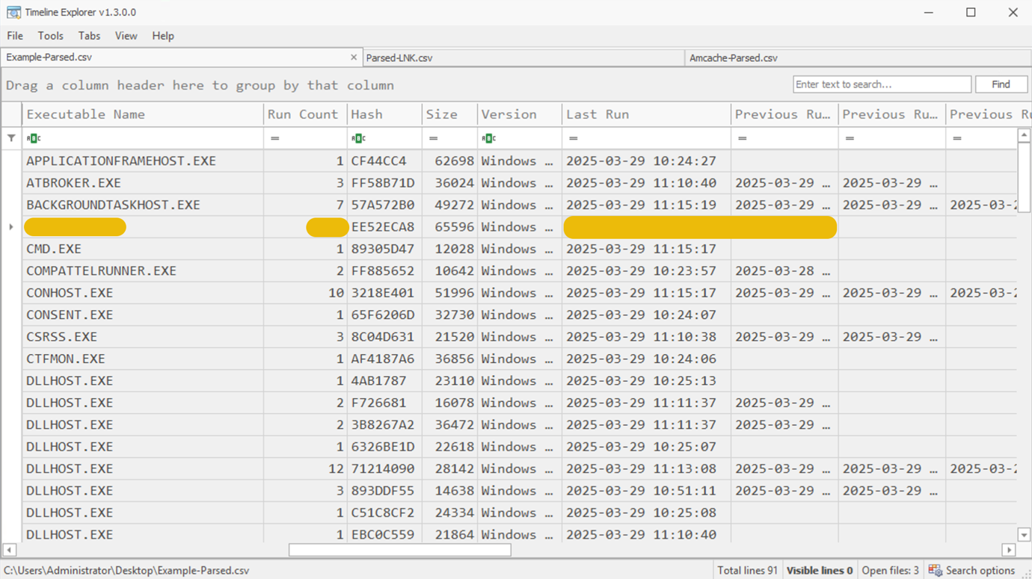

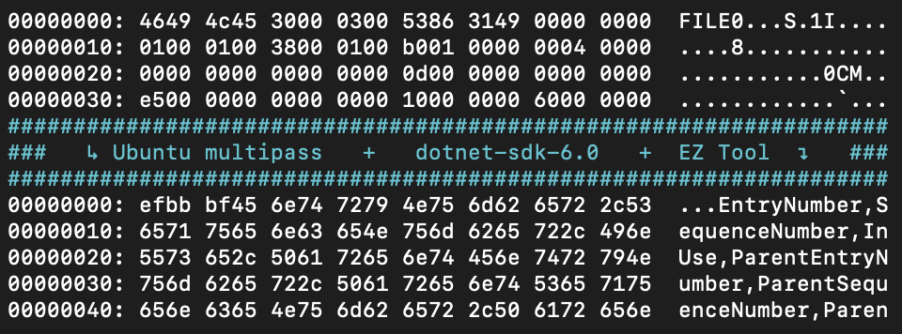

**Suspicious Entries Found**

RUNDLL32.EXE

POWERSHELL.EXE

MIMIKATZ.EXE (renamed)

CURL.EXE

**Why it matters:**

Prefetch shows **recently executed programs**, even if deleted.

**Amcache Analysis (Program Install/Run Traces)**

Using **AmcacheParser.exe**.

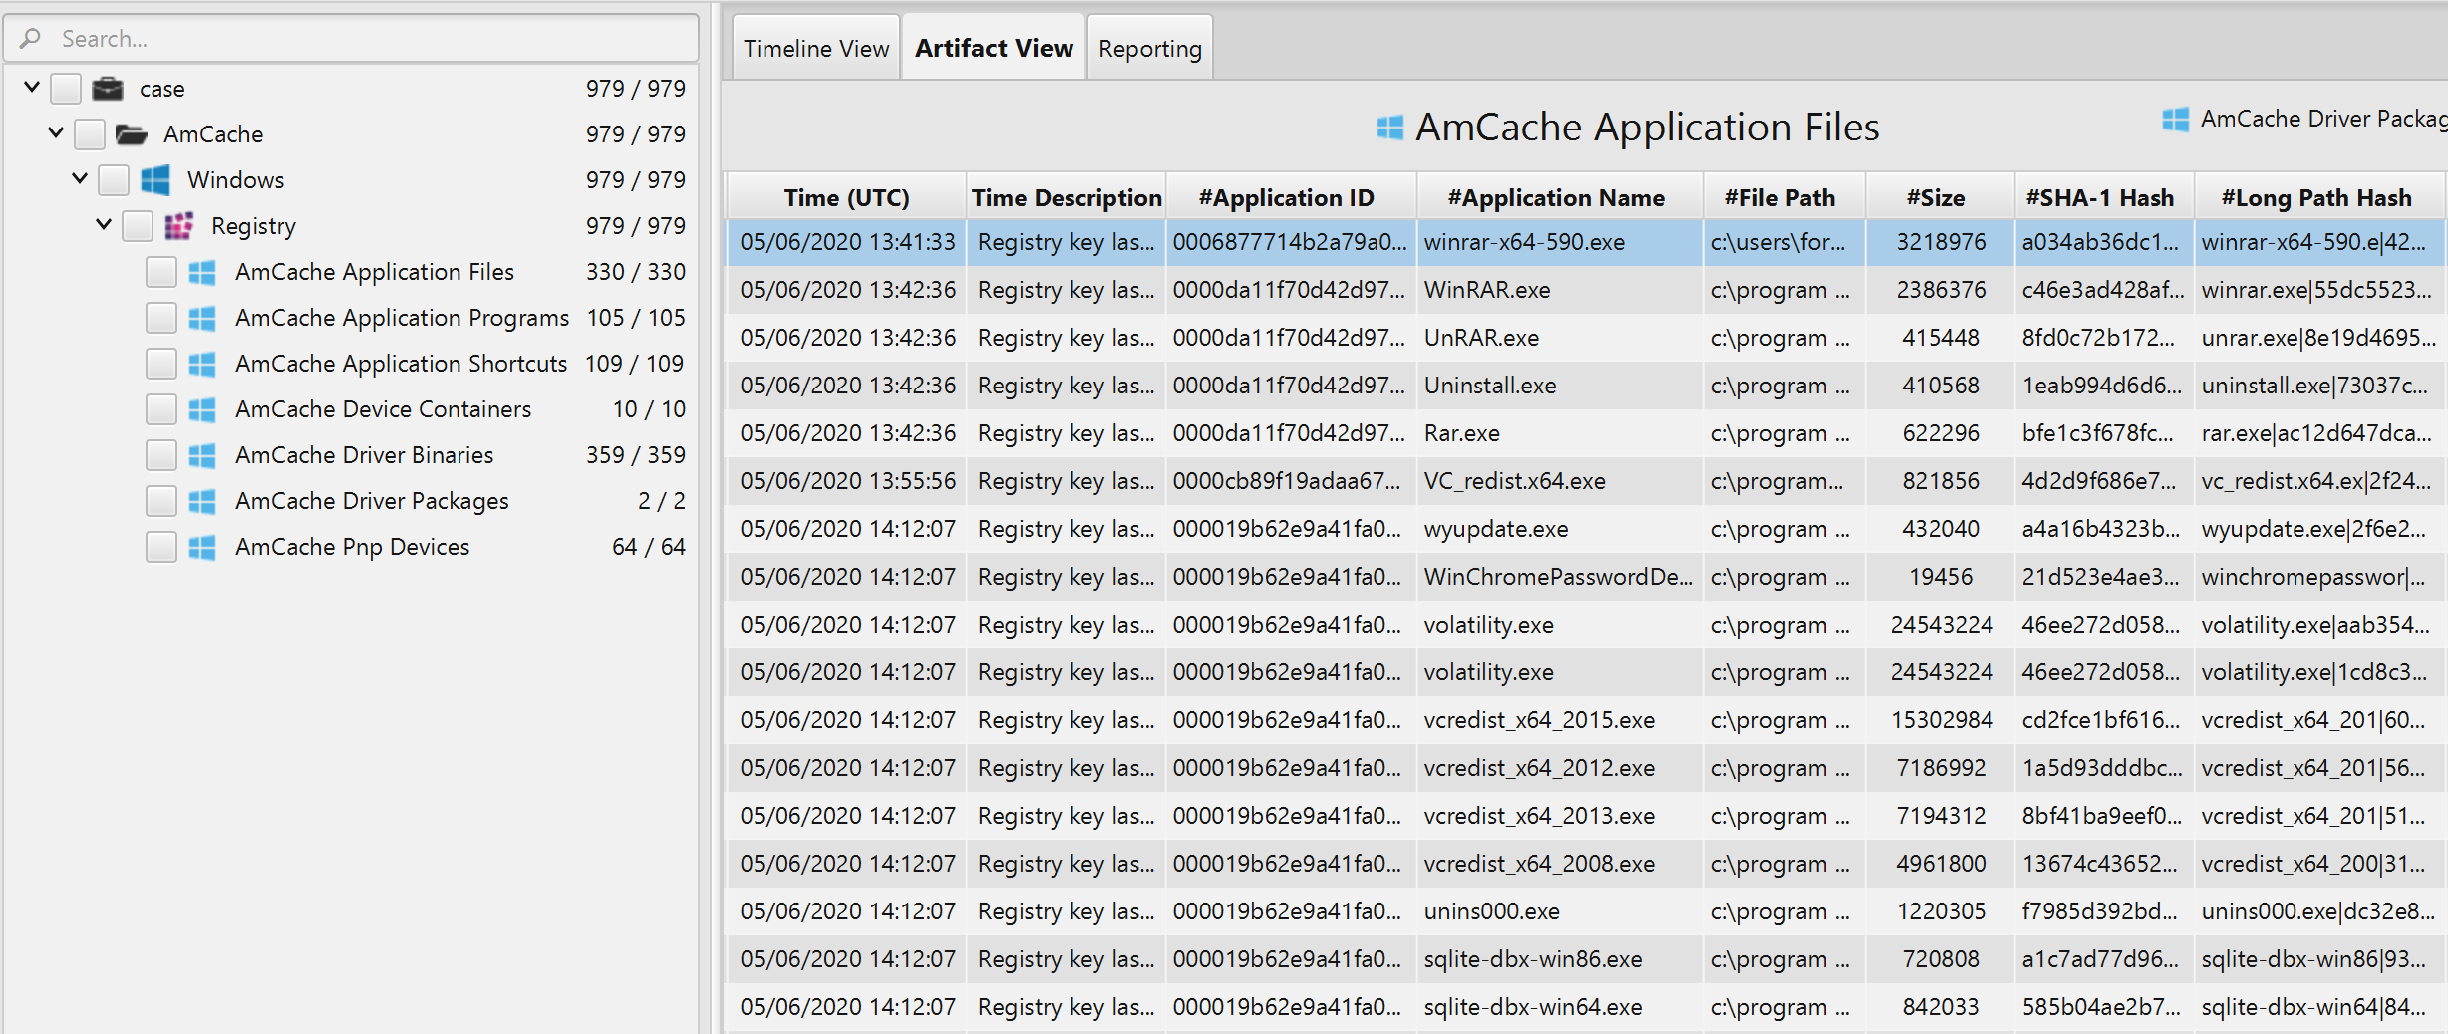

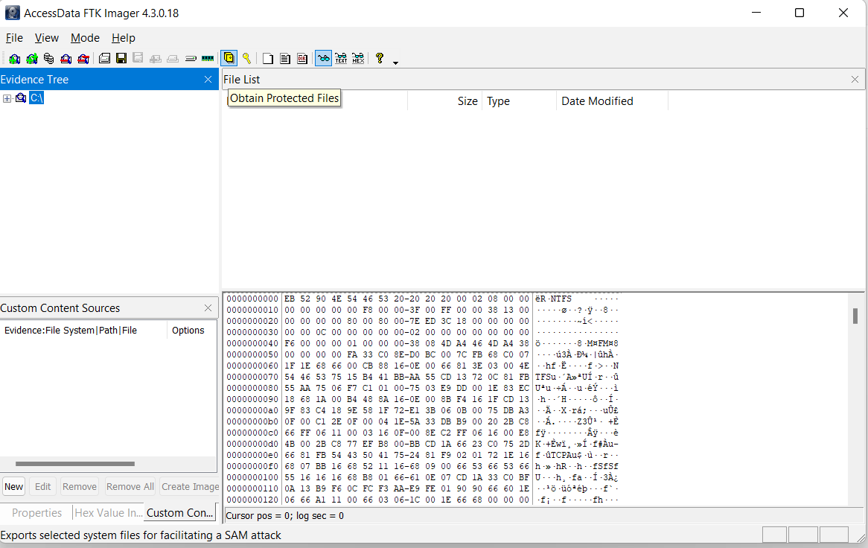

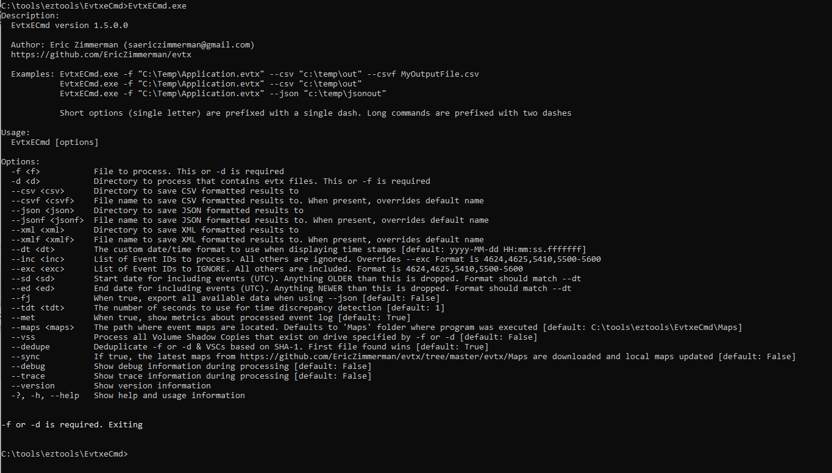

**Findings:**

* Suspicious binary updater.exe installed in %APPDATA%
* First run timestamp recorded

**ShimCache / AppCompatCache**

Shows execution history of programs.

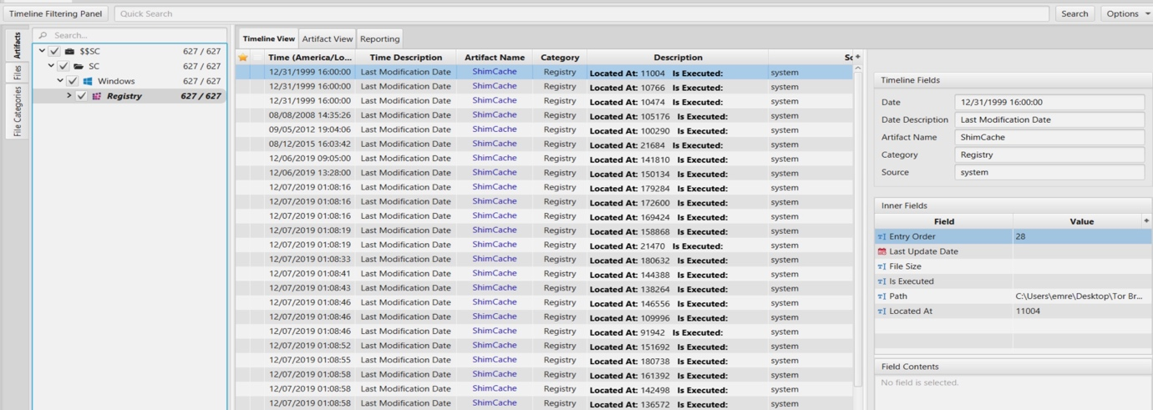

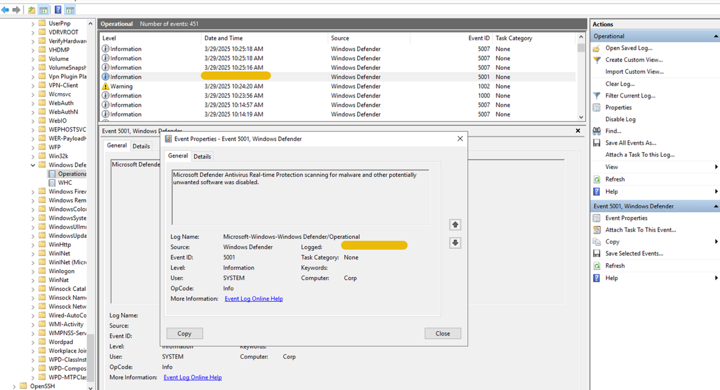

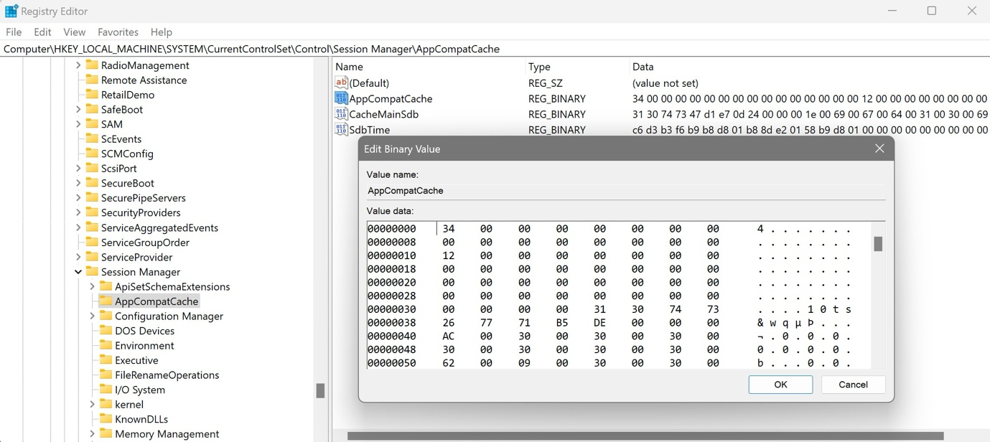

**Findings:**

* payload.dll executed despite deletion
* Matches malicious activity in timeline

**$MFT (Master File Table) Analysis**

Using **MFTECmd.exe**.

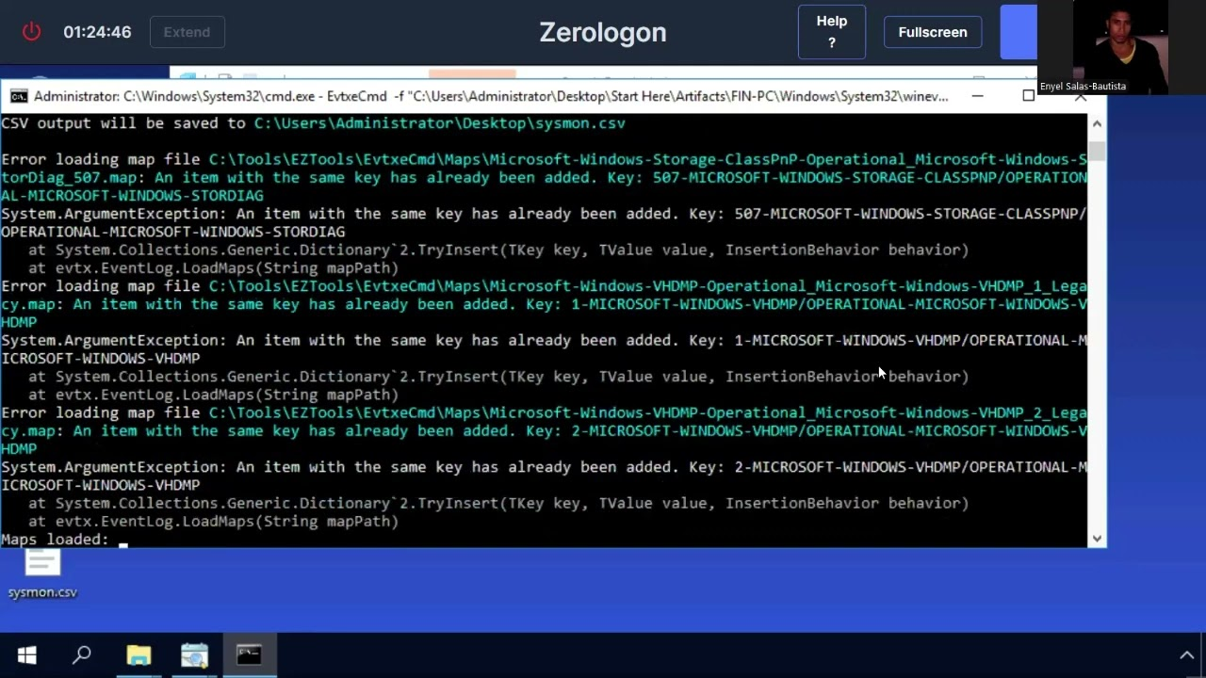

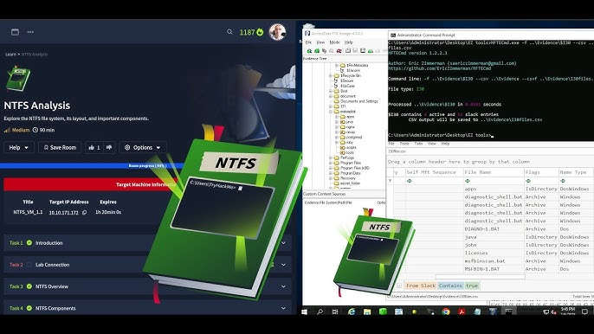

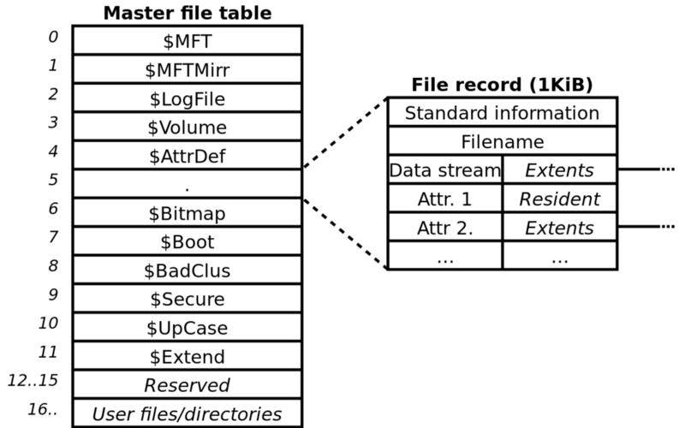

**Findings:**

* Hidden directory created: C:\Users\Public\Libraries\Temp
* Deleted EXE recorded with timestamps
* timestomp activity suspected

**USN Journal Analysis (File Change Tracking)**

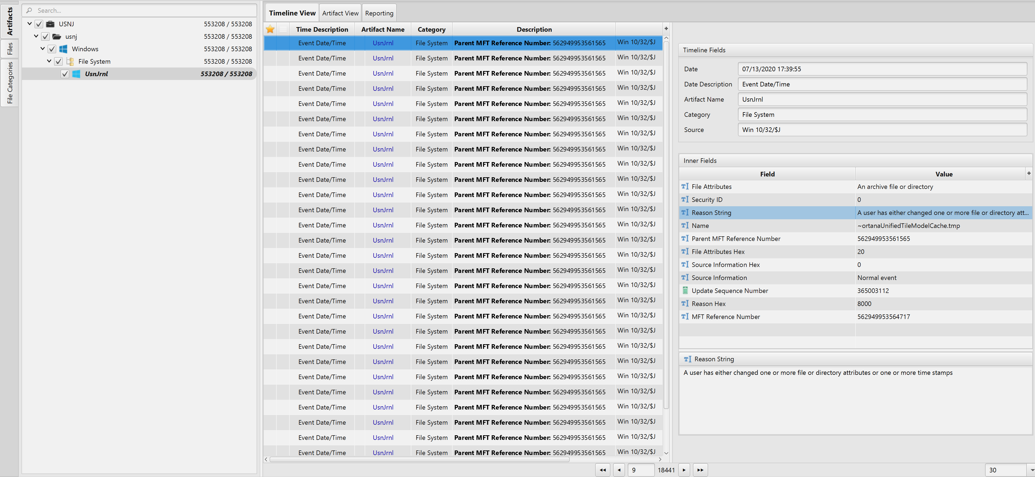



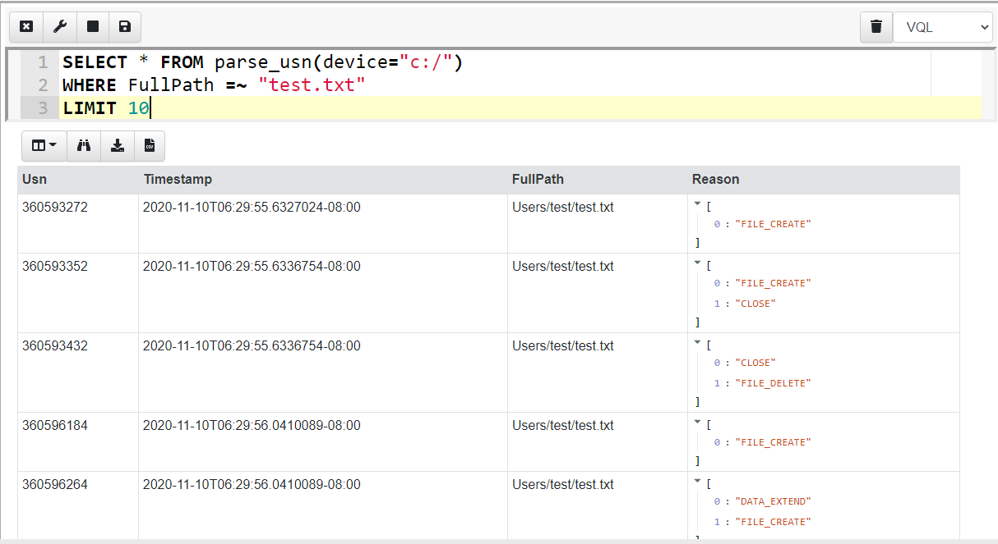

**Observations:**

* Rapid modification of ≥200 files within 10 seconds  
  → Possible ransomware staging behavior
* Creation of new DLL and EXE in AppData

**Registry Forensics**

Registry reveals persistence, autoruns, and user activity.

**Run Key Persistence**

HKCU\Software\Microsoft\Windows\CurrentVersion\Run\Updater

Value:

C:\Users\John\AppData\Roaming\updater.exe

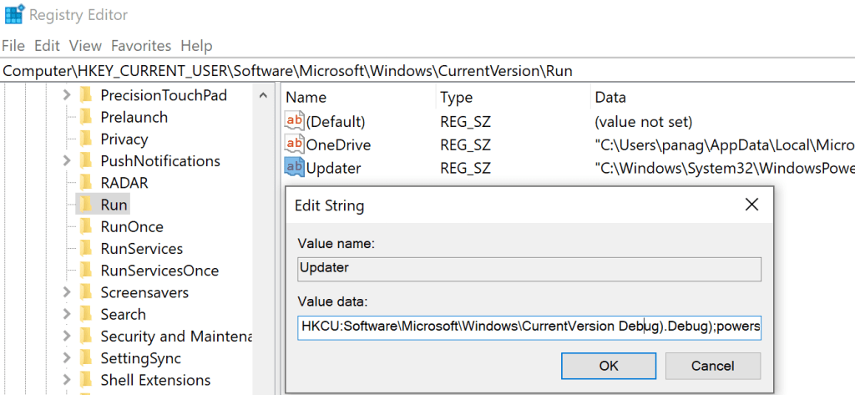



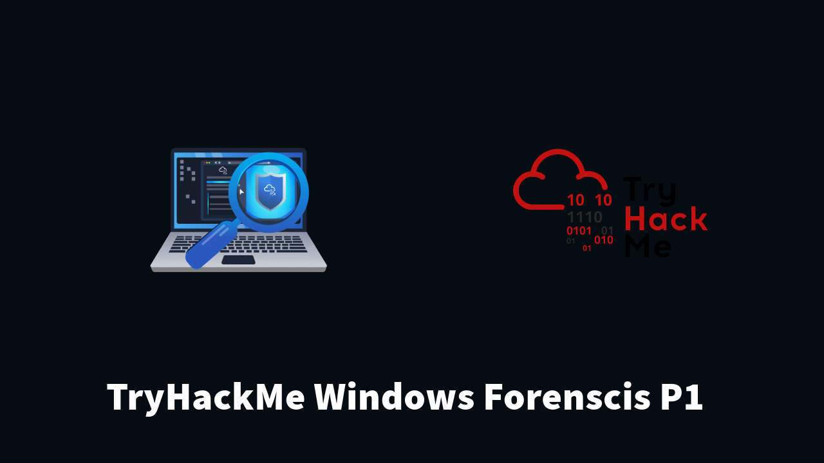

**UserAssist Program Execution**

Decoded to show GUI apps run by user.

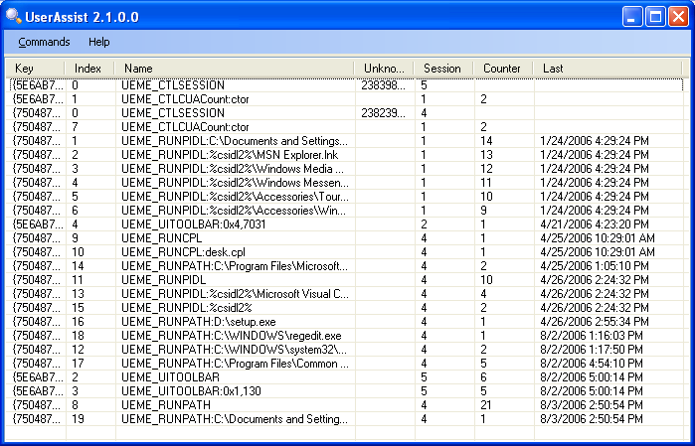



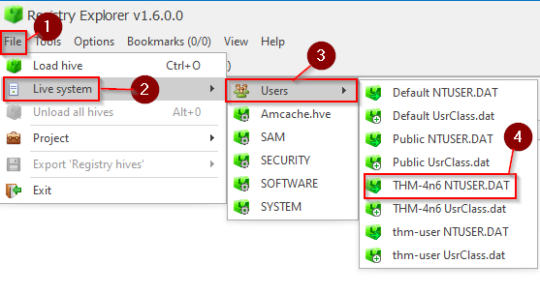

Findings:

* User launched PowerShell before malware execution

**SAM & SECURITY Hive Analysis**

* Found newly created local admin user
* Privilege escalation confirmed

**Memory Forensics**

Memory dump loaded into Volatility.

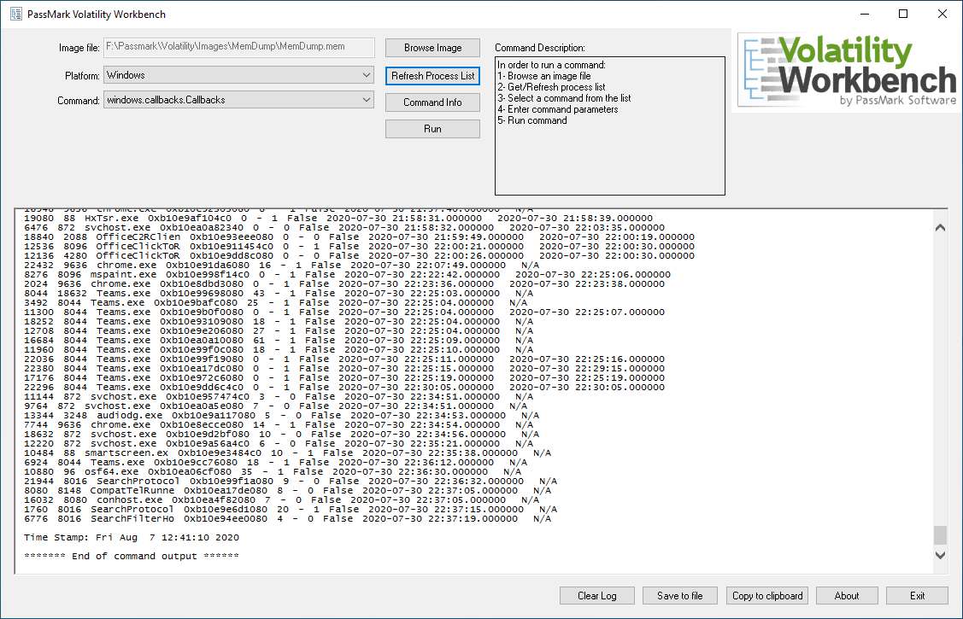





**Process List**

Suspicious process:

updater.exe (PID 1804)

Parent:

rundll32.exe

**Malicious Network Connection**

volatility3 windows.netstat.NetStat

Output:

* outbound → 188.166.xxx.xxx:443 (DigitalOcean VPS)

**Detecting Credential Dumping**

volatility3 windows.callbacks.Callbacks

Found:

* LSASS memory access handle from updater.exe

**Injected Threads**

volatility3 windows.malfind.Malfind

Found multiple injected PE sections in memory.

**Complete Timeline (Plaso + Log2Timeline)**

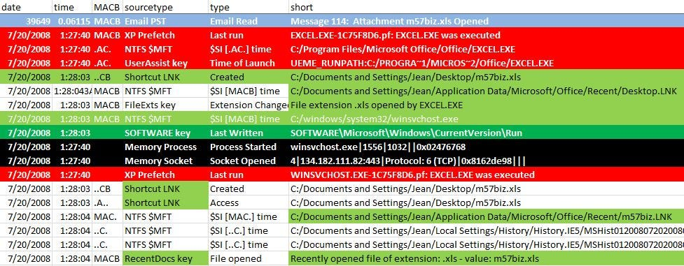

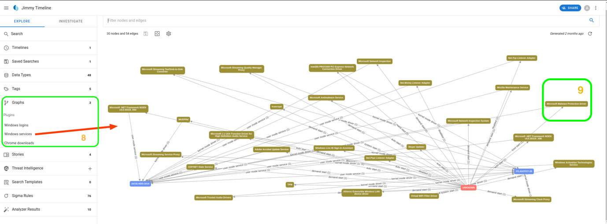

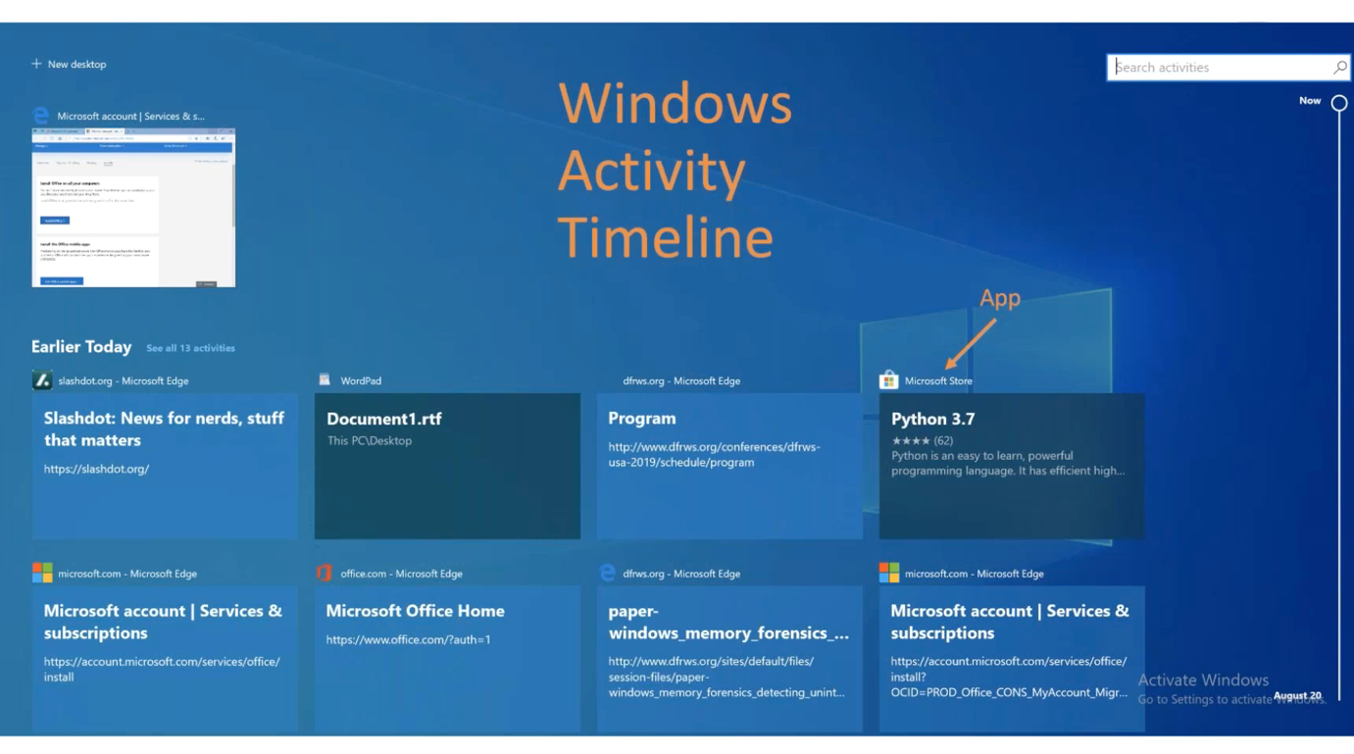

| **Time** | **Event** |
| --- | --- |
| 13:59 | User opened malicious PDF |
| 14:01 | rundll32 executed payload.dll |
| 14:03 | updater.exe dropped |
| 14:04 | PS UAC bypass attempted |
| 14:05 | LSASS accessed |
| 14:07 | Persistence key added |
| 14:10 | Data exfil via TLS |

Everything ties together clearly.

**Correlating DFIR Findings with SIEM Logs**

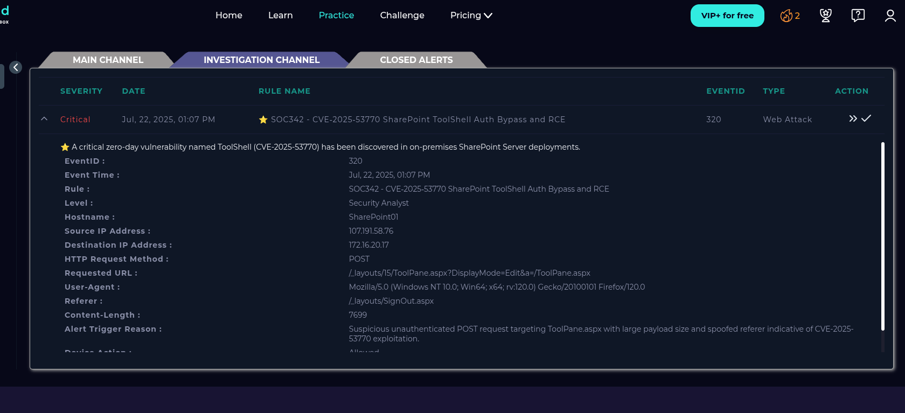

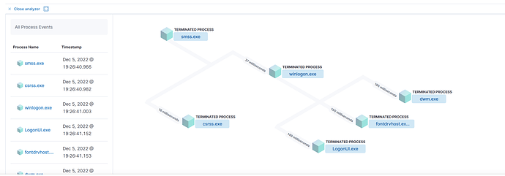

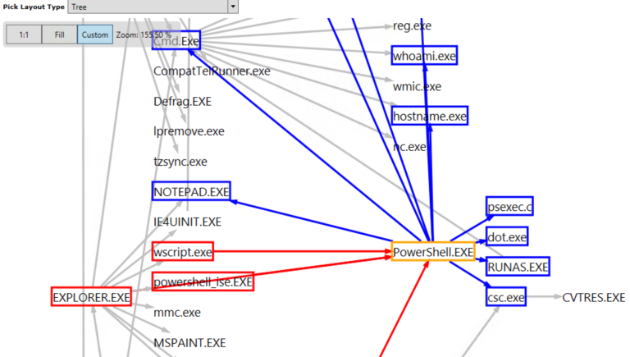

Sysmon Data Confirmed:

* Event 1: Process Creation (PowerShell, rundll32)
* Event 10: LSASS access
* Event 13: Registry RunKey
* Event 3: Network Connections

Sentinel Correlation Triggered:

* Unusual Rundll32 Behavior
* Possible Credential Access
* Persistence Mechanism

**MITRE ATT&CK Mapping**

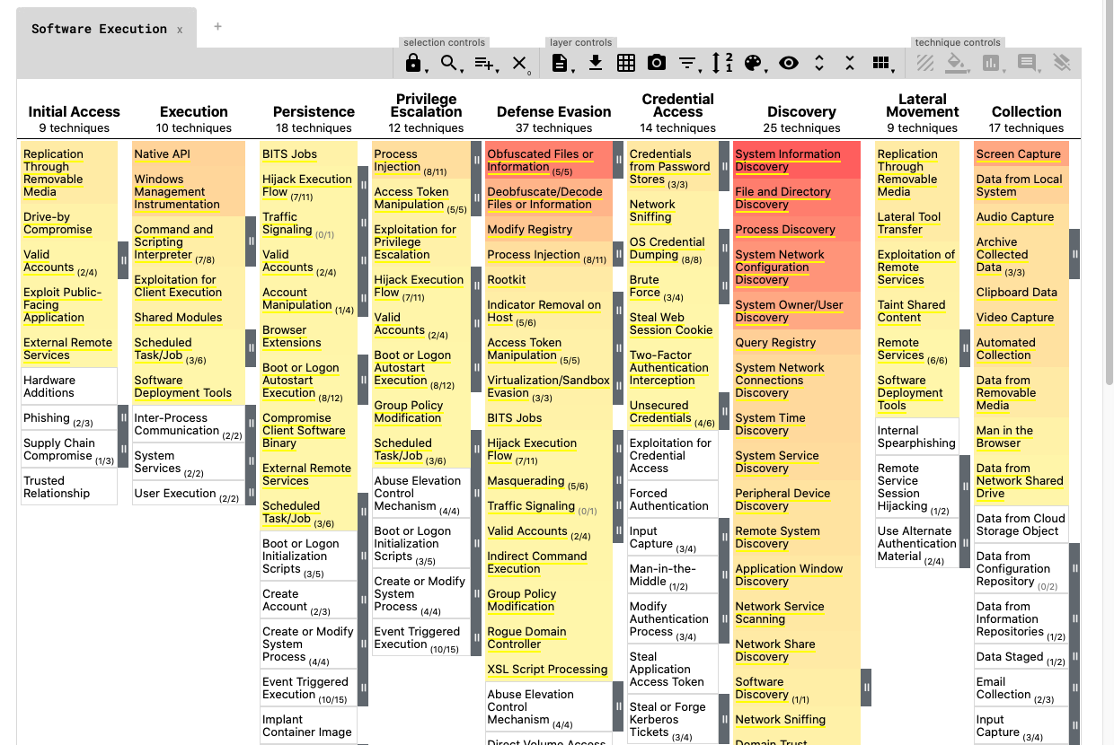



| **Technique** | **ID** |
| --- | --- |
| Initial Access (Phishing) | T1566 |
| Execution (Rundll32) | T1218 |
| Privilege Escalation | T1548 |
| Credential Access (LSASS) | T1003 |
| Persistence (Run Key) | T1547.001 |
| Defense Evasion | T1070 |
| Command & Control | T1105 |
| Exfiltration | T1041 |

**Executive Summary**

**✔ Evidence of malware execution confirmed**

**✔ Persistence mechanism added**

**✔ Credential dumping attempted**

**✔ Network exfiltration observed**

**✔ User activity aligned with attack chain**

**✔ Memory confirmed injected malicious threads**

**✔ Disk-level artifacts validated executed files**